**HOW TO READ A COMPOSITE BALLOT**

Kenton County has 4 Senatorial Districts, 6 House of Representative Districts, a 3-Commissioner based County Government, 19 cities, 5 independent school districts and one common school district that has 5 divisions. This means there are many combinations for a ballot. Since it is difficult to post all the sample ballots for a General Election, a composite/publication ballot is produced for the voter to find all the races that will appear on their specific ballot. Composite ballots can be found at the following sites: [**Kentucky: Secretary of State - Online Services**](https://web.sos.ky.gov/electionballots/)and[**www.kentoncountykyclerk.com**](http://www.kentoncountykyclerk.com)

**Here are instructions on how to read the COMPOSITE/PUBLICATION BALLOT.**

1. First, you will need to know your precinct code and name. Visit [www.govoteky.com](http://www.govoteky.com) and click on “Review your registration”. Put in your first name, last name and date of birth, your precinct code and name will be towards the bottom of the page. Here is an example:

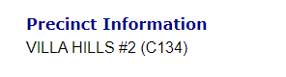

1. Once you know your precinct information, you go to [www.kentoncountykyclerk.com](http://www.kentoncountykyclerk.com) and under the Elections Tab, choose the Candidates/Composite Ballot. A composite ballot shows all the races that can appear on all the precincts.

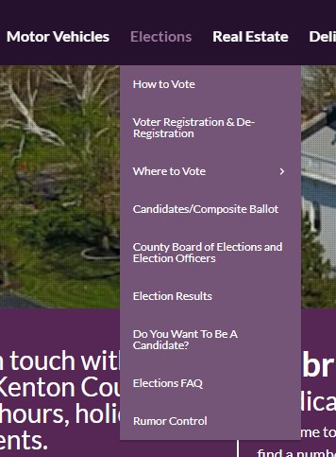

1. The first thing on everyone’s ballot will be the Straight Ticket option. This is convenience for the voter to choose a specific party and it will choose all the candidates who are in that political party. This means the voter would not have to fill in the oval in front of each candidate’s name for all the partisan races. However, this will not take care of any of the non-partisan races that will appear on a ballot, like school boards, or city races.

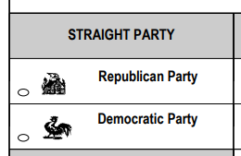

1. Next, there will be races that will have the words “ALL PRECINCTS” under the race. This means that this race will be on every ballot in the county.
2. The races that have specific precinct codes under them means that race will only appear on those precinct ballots. Here is an example under one of the races.



This is where you can find your precinct code and name of your precinct. In the example above, C140 FTM 1 is C140 Ft. Mitchell #1.

1. There is also language on the ballot that will say “PART OF”- See example below.



This means that this precinct has more than one ballot option because this precinct is split between two school boards or between a city and county property.