HOW TO READ THE LABELS ON MY MAIL-IN ABSENTEE BALLOT

If you have requested a mail-in absentee ballot, you will receive a packet in the mail that has two emvelopes (one white and one gold), your ballot and instructions. On all the envelopes there are bar codes, so you may wonder what all the information means.

When processing a mail-in ballot, three labels are produced per each voter. Reading from left to right on the example below, the first label goes on the outside of the envelope, the second label goes on the white return envelope and the third label goes on the gold privacy envelope for the ballot.
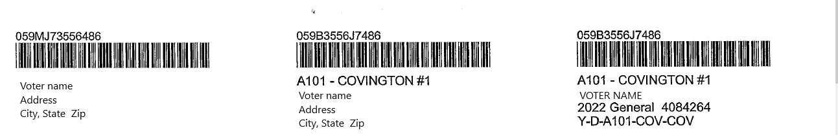

THE FIRST LABEL
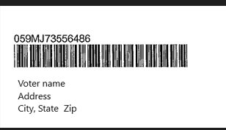

- The first label is on the large white envelope that contains the ballot packet for the voter so that the post office can deliver this to the voter.
- The series of numbers and letters on top of the bar code will be the same on the top of each label.
- The first set of numbers indicates the county code. In this example 059 indicates Kenton County
- The next letter “M” indicates that this label is for mailing the ballot
- The next set of letters and numbers are an encrypted combination of the voter’s identification number and the date and time that the voter requested a ballot.
- The bar code under the series of letters and numbers contains all that information so it can be scanned. This allows the voter to track when their ballot was processed and put into the mail. A voter can track their ballot at www.govoteky.com
- Finally, there is the name and address of the voter.

THE SECOND LABEL
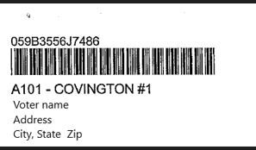

- The second label is on the smaller white envelope that is used to return the gold privacy envelope with the ballot. The label is placed in the upper left hand corner of the envelope in the return address area.
- The series of numbers and letters on top of the bar code will be the same on the top of each label.
- The first set of numbers indicates the county code. In this example 059 indicates Kenton County
- The next letter “B” indicates that envelope contains the ballot
- The next set of letters and numbers are an encrypted combination of the voter’s identification number and the date and time that the voter requested a ballot.
- The bar code under the series of letters and numbers contains all that information so it can be scanned. This allows the voter to track when the ballot was received in the County Clerk’s office pending review. A voter can track their ballot at www.govoteky.com
- Next is the precinct code and the precinct name for the voter.
- Finally, there is the name and address of the voter.

THE THIRD LABEL
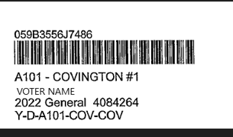

- The third label is on the golden envelope flap where the voter must sign again that they are the individual who put the ballot in the envelope. This flap is detached from the envelope during the review of the ballots to ensure the privacy of the vote. The label is placed at the top of the flap where the voter’s information is requested.

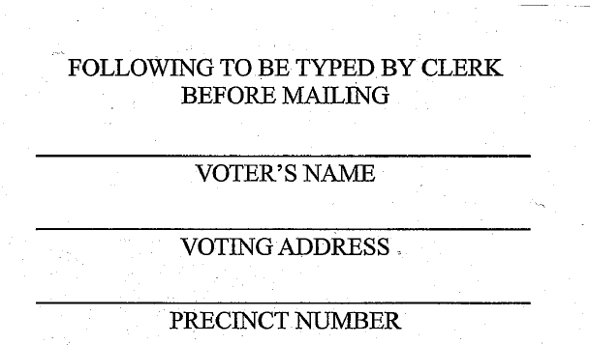
- The series of numbers and letters on top of the bar code will be the same on the top of each label.
- The first set of numbers indicates the county code. In this example 059 indicates Kenton County
- The next letter “B” indicates that envelope contains the ballot
- The next set of letter and number are an encrypted combination of the voter’s identification number and the date and time that the voter requested a ballot.
- The bar code under the series of letters and numbers contains all that information so it can be scanned. This allows the voter to track when the ballot was received in the County Clerk’s office pending review. A voter can track their ballot at www.govoteky.com
- Next is the precinct code and the precinct name for the voter.
- Voter name.
- The Election year, type of election (Primary or General) and voter identification number.
- The final line means the following
  - Yes, voter is eligible for a ballot “Y”
  - Voter party affiliation: “R” for Republican “D” for Democrat “I’ for Independent “L” for Libertarian or “O” for Other
  - Precinct code: Will start with either an “A”, “B” or “C” (i.e. A101)
  - City or County code : i.e. “COV”
  - School board code: i.e. “COV”

NOTE:
These bar codes do not match up with the bar codes on the ballots. The bar codes on the labels are for scanning the ballots in and out of the portal so the voter can track their ballot progress through www.govoteky.com
The bar codes on the ballot are for the acceptance of the ballot into the scanner.

