HOW TO REVIEW PRECINCT MAPS FOR KENTON COUNTY

Follow these steps to look at Kenton County precinct maps. If you want to look at your specific precinct you will need to know the state code and name of your precinct. To find that please visit www.govoteky.com and click on “Review your registration” Put in your first name, last name and date of birth and hit ‘SUBMIT”. Your precinct code and name will be towards the bottom of the page. See the example below.

- Go to Planning Development Services of NKY website at LINK-GIS Map Viewer (linkgis.org).

- After you agree to the disclaimer, you will get the following screen on the GIS Map Viewer. There are many tools on this page. The one you want to click on is the picture of the layers surrounded by the red box. This adds additional layers and options to the map.

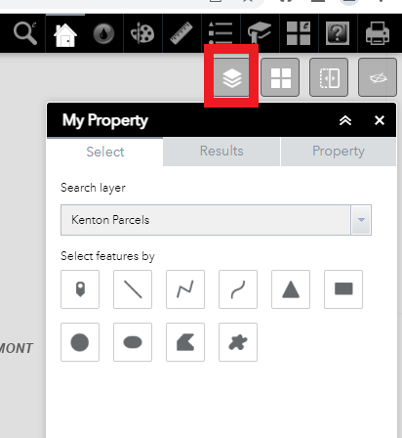

- Click on the layer icon. You will get a list of options called “MORE LAYERS”. One of those layers is “Voting”. Click on the box before the word “Voting”. A check mark will appear and adds the voting layer to the map.

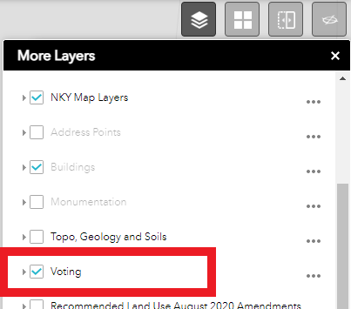

- Use the mouse to scroll to enlarge the image. To find your specific precinct, you need to search the map for your precinct code (i.e. C134). The precincts are shaded different colors, precinct code and flags to indicate polling locations. Click on the precinct number or flag to get additional information.

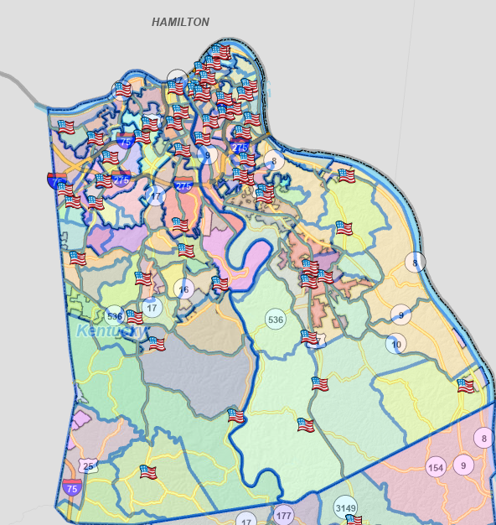

EXAMPLE OF PRECINCT CODES: CLICK ON THE NUMBER TO GET PRECINCT INFORMATION
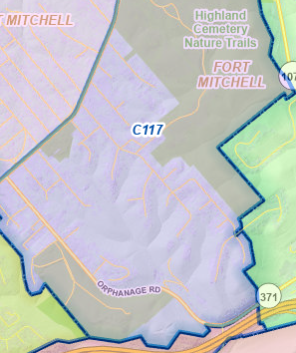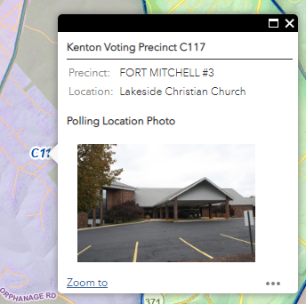

EXAMPLE OF FLAGS: CLICK ON THE FLAG TO GET PRECINCT AND LOCATION INFORMATION
